**Users’ Manual of SPOLERC**

***Step1: software installation***

The SPOLERC has been compiled, you can use it directly on your PC (we don’t have a Mac version currently). Please double-click “DblclickMe”(C:\Application\DblclickMe) or the “spolerc.exe”(C:\Application\dist\spolerc) can run, you do not need to install any software.

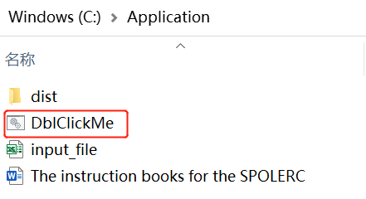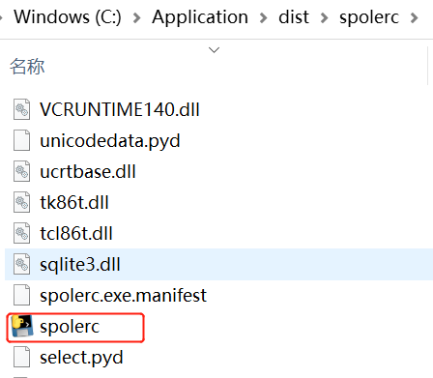

***Step 2: document preparation***

First of all, it is recommended to put all relevant files of SPOLERC into the same folder. The Spaces and non-Latin letters should not occur in file names to avoid the possibility of running errors. For example, please name your input files by “input_file.xlsx”, we don’t encourage filenames such as “输入 文件.xlsx”.

Secondly, prepare the “input_file.xls” (note that it is a file with an extension of xls, not xlsx) in the same format as the example file. It is worth mentioning that the first column of the file is the ordinal number, the second column is named “OP”, and the third column is named “LP”. The “input_file.xls” should be placed in the same directory as the batch file (with the extension "bat").

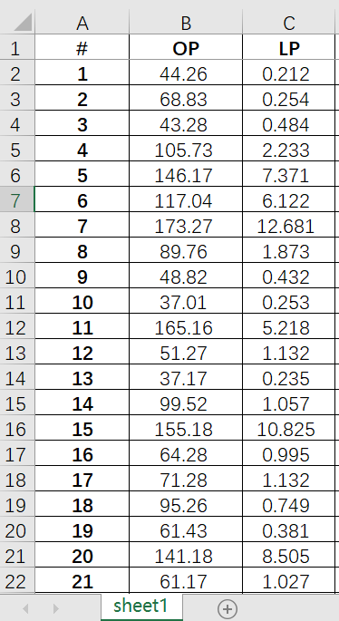

***Step 3: software runs***

First of all, enter the file location after the input file path: such as "C:\Application\input_file.xls". Be careful to ensure that the entire path has no space and no Chinese as far as possible to ensure that the following run will report fewer errors.

Secondly, enter the form name, such as “Sheet1” or a user-named form Name in the right column of the “Input Sheet Name” on the main SPOLERC screen, and make sure that the case is the same as the “input_file.xls”.

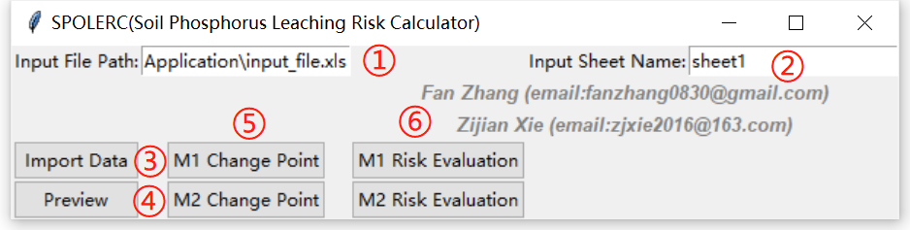

Thirdly, click the “Import Data” button on the left to import the Data. The program will automatically pop up the interface as shown in the following picture to prove that the data entry is complete. Click OK to continue.

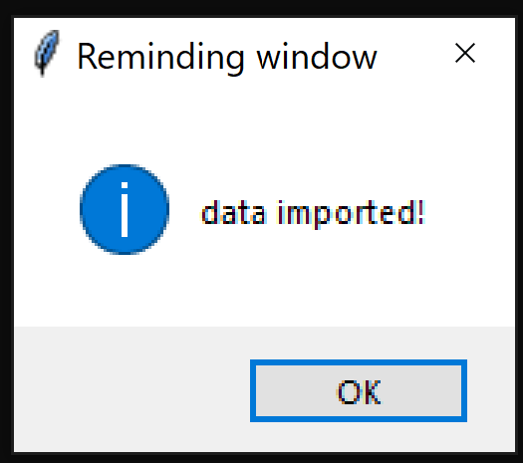

Fourthly, click the "Preview" button to preview the data points and determine the data processing mode. The SPOLERC software automatically calls the system's default browser to display the results. Then, the calculated mode was selected based on the preview figure.

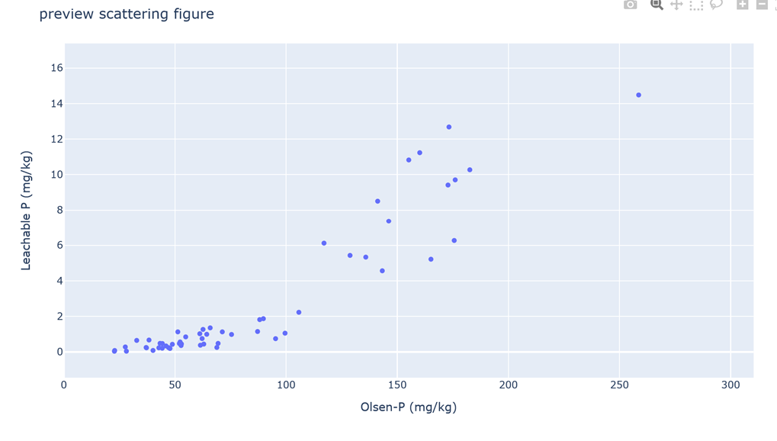

Fifthly, it assumes that the data structure conforms to Model 1, click on "M1 Change Point" and calculate the soil P leaching change point according to the “Mode 1”.

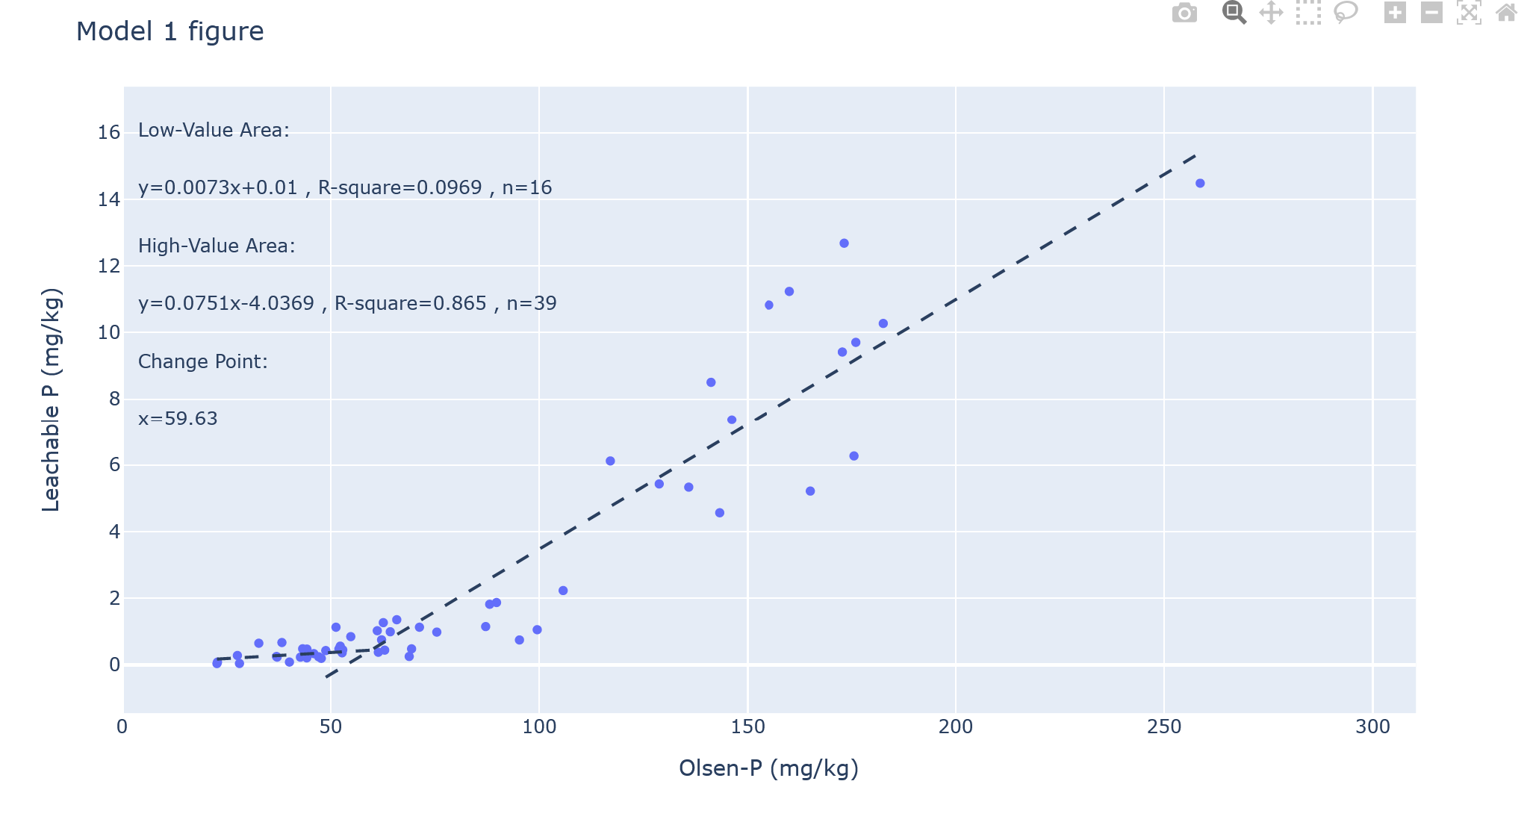

Then, click on "M1 Risk Evaluation" to carry out the risk assessment according to the “Mode 1”.

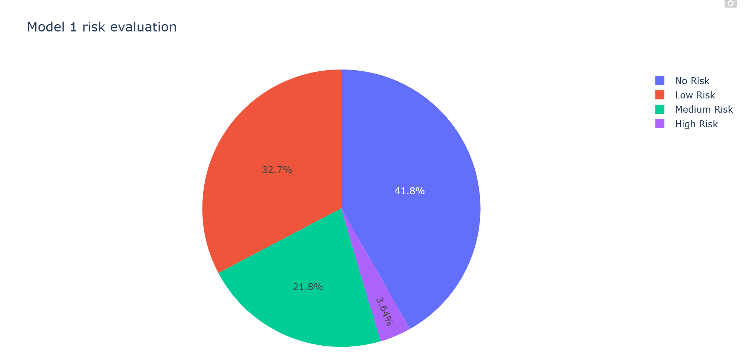

Similarly, click on "M2 Change Point" and calculate the soil P leaching change point according to the “Mode 2”, and, then, click on "M2 Risk Evaluation" to carry out the Risk assessment according to the “Mode 2”.